THE TRANSPORT FOR GREATER MANCHESTER (LIGHT RAPID TRANSIT SYSTEM)
(TRAFFORD PARK EXTENSION) ORDER 2016

BOROUGH OF TRAFFORD (BRIDGEWATER CANAL TOWPATH, TRAFFORD PARK) (TEMPORARY STOPPING UP) ORDER 2018 Ref – TPL 0079

NOTICE IS HEREBY GIVEN that pursuant to the provisions of Article 14 of The Transport for Greater Manchester (Light Rapid Transit System) (Trafford Park Extension) Order 2016, Transport for Greater Manchester (TfGM) intends to Temporarily Stop Up the length of footpath/cycle route specified in the Schedule below.

SCHEDULE – Temporary Stopping Up

Footpath/Cycle route | Length Affected
Footpath/cycle route on the Bridgewater Canal Towpath | Between its junction with the footpath/cycleway access to Barton Square and the footpath/cycleway to the east of Parkway. More clearly shown in the image below.
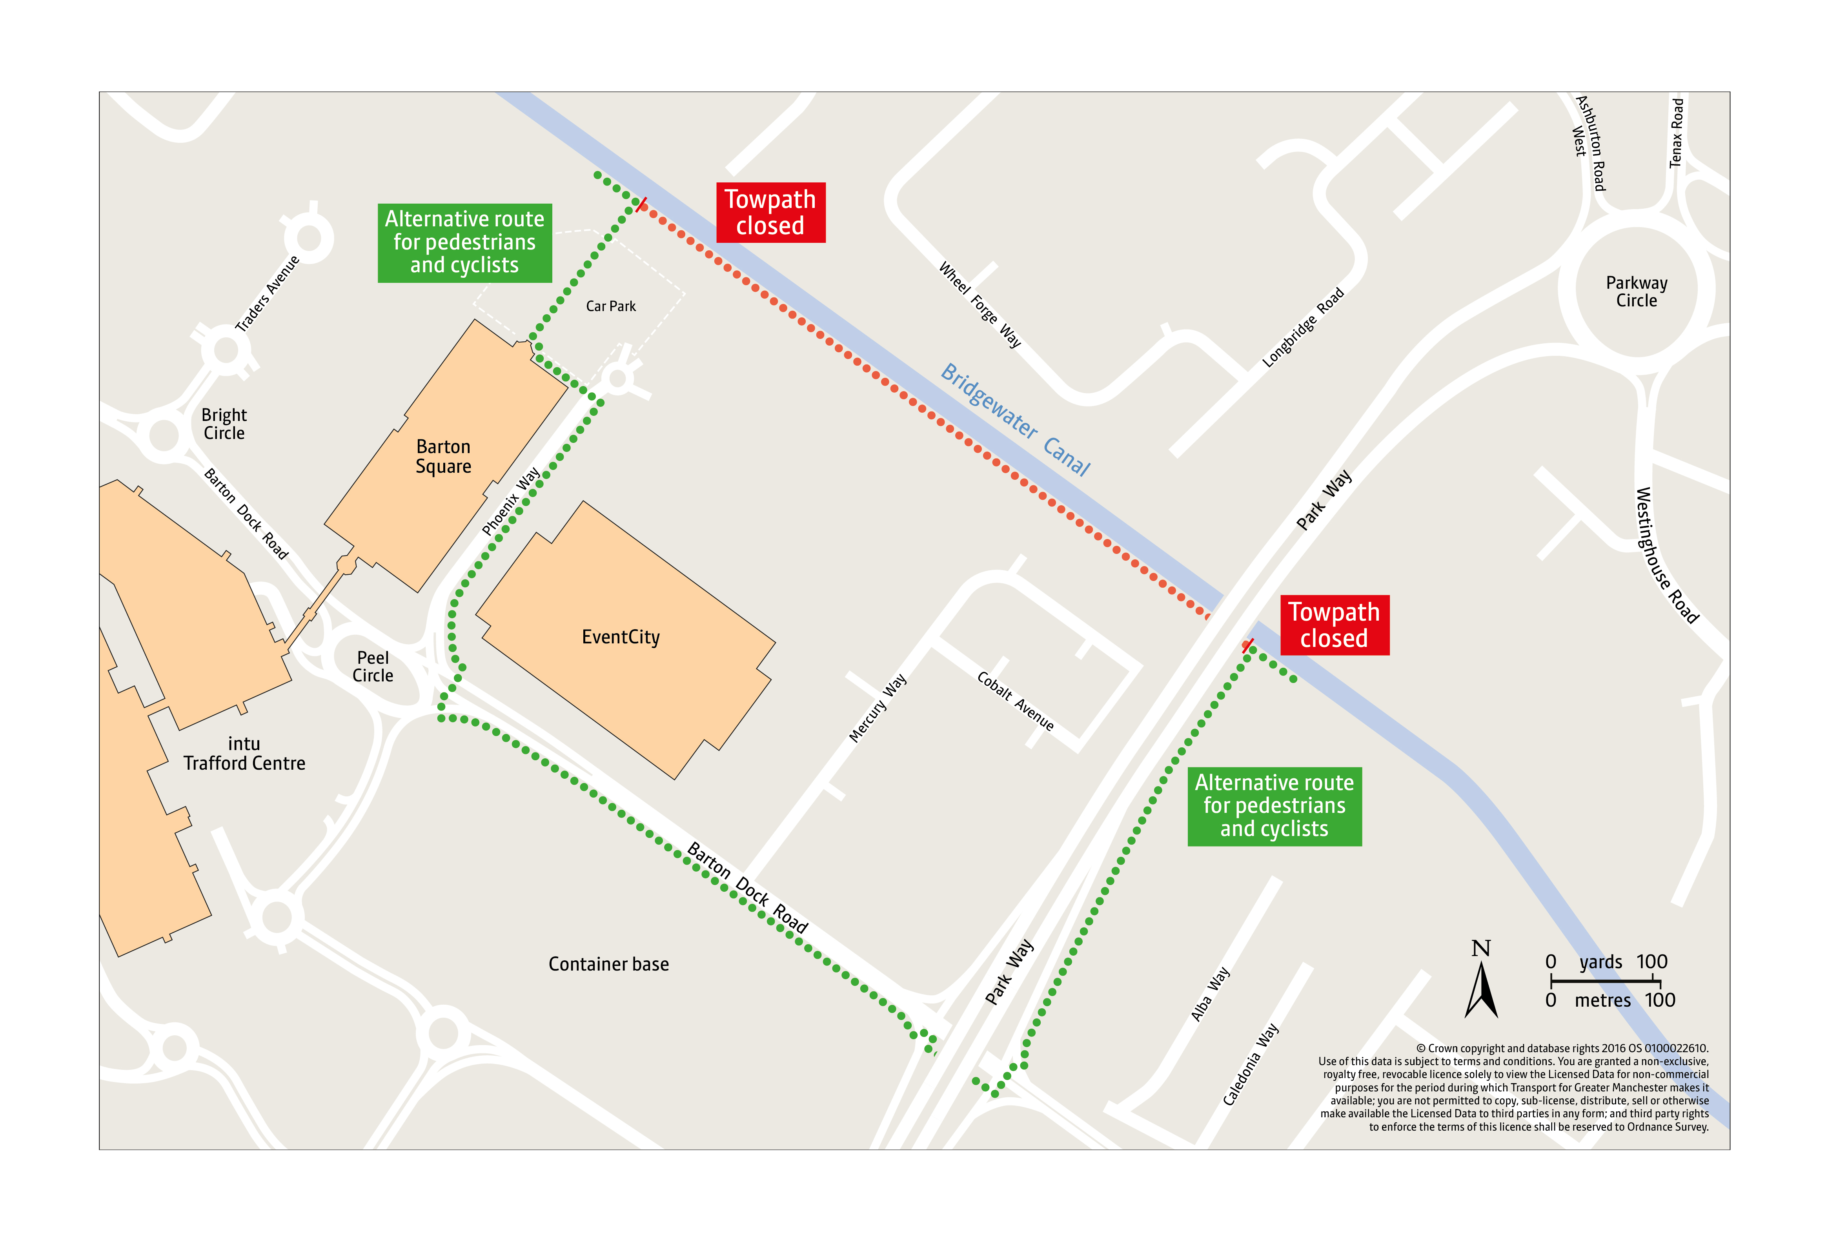
The reason for the order is to maintain pedestrian and cycle safety during the installation of the bridge deck on the new bridge being constructed adjacent to Parkway in connection with the Metrolink extension works.

The alternative route for pedestrians and cyclists is via Barton Square, Phoenix Way, Barton Dock Road and the footway/cycleway to the east of Parkway that links onto the southern side of Bridgewater Canal.

The order will come into force on 8th September 2018 and will remain in force for 2 days (or until the safe completion of the work). However, if adverse weather or unforeseen circumstances affects the ability to undertake the works on the weekend of the 8th/9th September the Order will be introduced the following weekend from 15th September to 17th September 2018.

Dated: 10th day of August 2018

Transport for Greater Manchester
2 Piccadilly Place,
Manchester
M1 3BG

